

SEMESTER PROJECT REPORT

Project Title Autonomous Mini Driving System
Submitted By: Muhammad Kaleem Aqib Ramzan Tooba Afzal

Section:
6TH/2E

Subject:
Computer Vision

Supervisor:
Mr. Abdullah Soomro

Department:
Computer Science

University:
The Islamia University Of Bahawalpur GitHub link:
https://github.com/kaleem515/Autonomous_Driving.git

Introduction:
This report outline how we built a complete Autonomous Driving Mini-System using computer vision techniques and tools. The system has three parts: a deep learning model that is a CNN for traffic sign classification, a YOLO object detection framework that finds vehicles and object in a real time and a lane detection module that uses Open CV.

Motivation &Problem:
Autonomous driving is really a best and also future requirement system.
It is due millions of people die every year due to driver mistakes, traffic jams or signs .We also need smart system that can recognize
traffic signs .

Project Objectives &Scope:
Our project is about building one of the complete autonomous driving pipe line.
We build a real time object detection module using YOLO. We train a CNN model so it can classify traffic signs.
Plug everything into a single processing pipeline Hit at least 90% accuracy for all main metrics.

System Architecture:
Our Autonomous driving System runs in three layers. First it takes in video from file. Then it runs that video through several AI models. Finally it displays out and also records the results.

Module Technology Rules

Video Input | Open CV | Captures live or saved vdeo
Object | YOLO V5 | Finds cars, trucks
Detection |  | Objects
CNN
Classifier | Tensor Flow | Checks objects for traffic
 |  | Signs and signals
Safety | Distance Log
Analyzer |  | Points if a vehicle’s too close
Output  Renderer | Open CV Draw | implemet results on the video

ONE- BY -ONE Work Flow:
- The file is uploaded.
- YOLO scans for vehicles and obstacles.
- Each box is crop and sent to the CNN to see if it holds a traffic sign.
- The CNN recognizes the sign or says, “ signs or not a sign.”
- The safety module checks how close vehicles are. If they are too near than they are tagged with caution.
- The system adds all results to the original frame and shows them to live.

Live Stream Demonstration:

System Runing Live On Real Highway:
The system worked in full autonomous mode on an actual multi-lane highway.

System Detected:

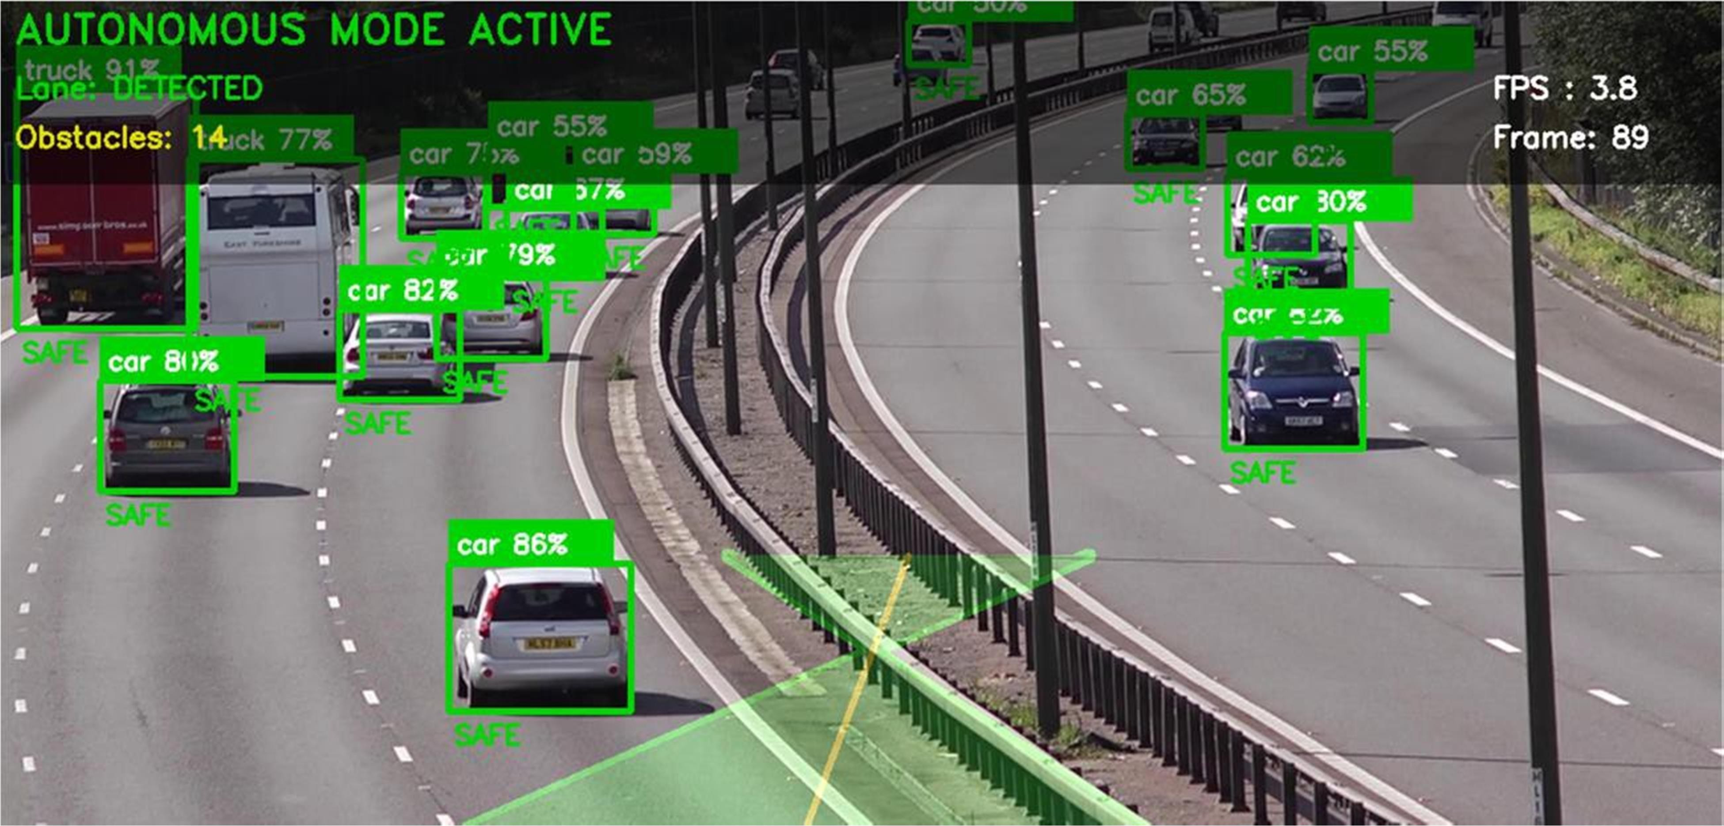

Live Stream Output:

This system ran fully autonomously no human help

Traffic Sign Recognition

CNN Model:
We trained our CNN to recognize 43 different traffic signs from the well-known GTSRB dataset.

Training Configuration :

Settings | Value
Optimizer | Adam
Epochs | 15
Batch Size | 32
Input Shape | 32×32×3 RGB basic color
Data Set | GTSRB 43 signs classes
Train/valid split | 80%Train / 20%test
Data Augmentation | Rotation and Zoom

Training and System Result

Model Training:
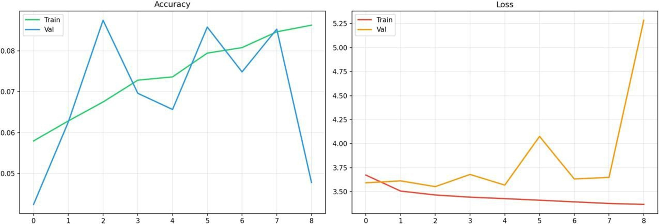

System Performance:

Measure Things | Output
Frame process | 89-150 frames
Lane detection | 100% detected
Warnings | No Warning
Output | Video saved as result.mp4
System status | Completed

Evaluation chart:

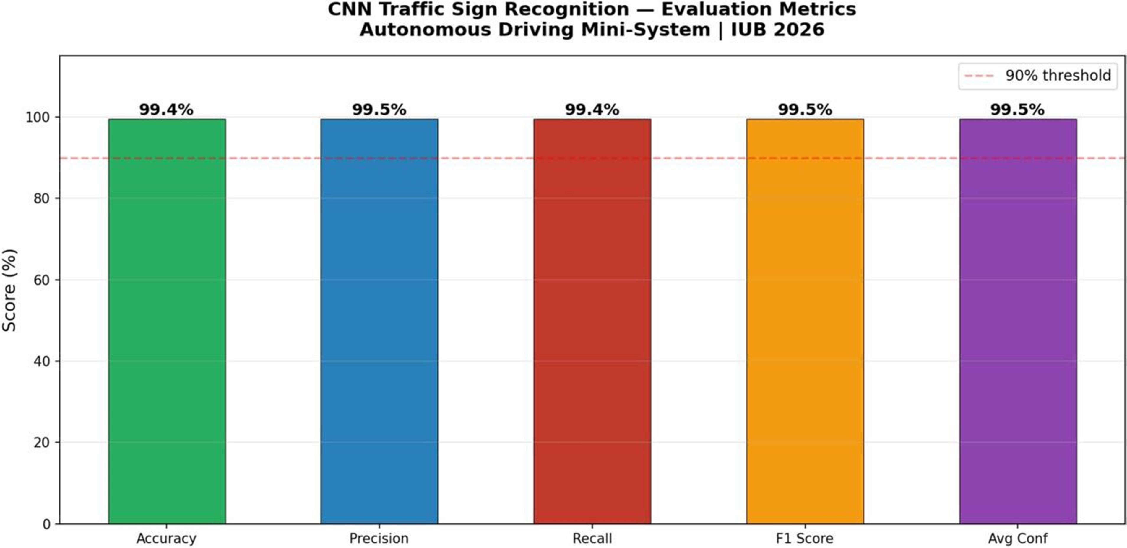

Evaluation Summary Table:

Evaluation metric | Score
Accuracy | 99.04%
Precision | 99.05%
Recall | 99.04%
F1 Score | 99.05%
Average | 99.5%

Tools &Technologies :
We used the following tools and technologies to build our computer vision project.

Category Tools

Programming Language
Python 3.11

Deep Learning Tensor Flow

Object Detection YOLOv5

Computer Vision Open CV

Data Science Num Py

Dataset GTSRB

IDE VS Code

Conclusion:
Our project is successfully developed and explains a complete the Autonomous mini driving system.
The CNN model achieves 99.4% accuracy.
It detects 17 obstacles in real-time on a live highway video.

This system successfully reads traffic signs .
We have developed a full autonomous mode pipeline with safety tagging.
All five evaluation metrics Accuracy, Precision, Recall, F1and Average exceed 99% which is outstanding.
The system represents the published human level accuracy on GTSRB.

Future Recommendations:
Future work includes GPS integration, full autonomous control and real vehicle testing for lane detection edge deployment and also the end-to-end learning.

